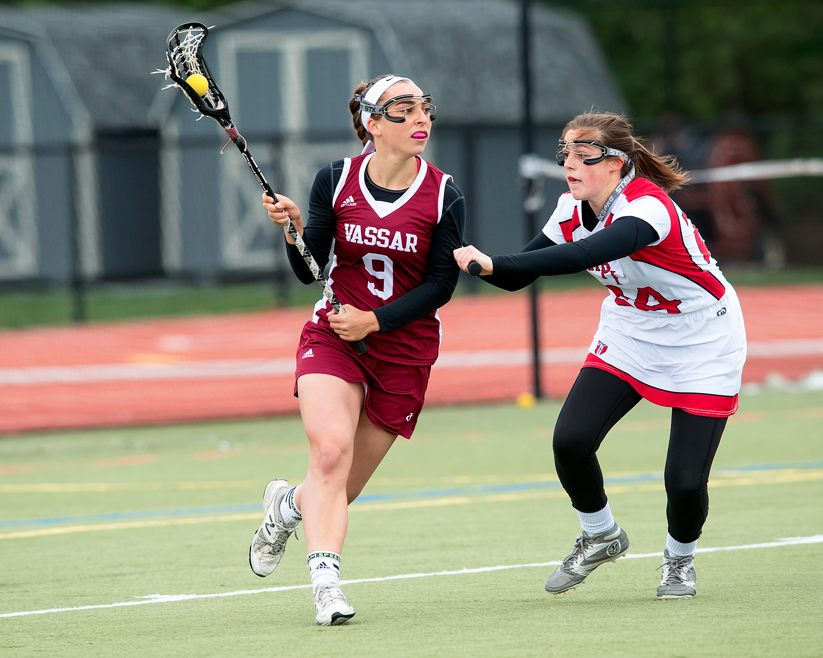 

**ABOUT:** The Vassar Girls Lacrosse Camp is designed for current high school players who are passionate about the sport and have aspirations to improve their game and compete in college. Participants will receive high-level instruction from college coaches, as well as speed and agility sessions conducted by the Vassar Strength and Conditioning Coach. Goalkeepers will also receive specialized coaching.

**COACHING STAFF:**

Vassar College Head Coach – Judy Finerghty

Vassar College Assistant Coach - Mark Feltch

OTHERS TBA

**SCHEDULE:**

**Friday, June 29**

8:00 – 9:15 am   Check-In/Move-In

9:30 - 9:45 am Camp Welcome

10:00 – 12:30pm Field Session I

12:30 – 1:30 pm Lunch

2:30 – 4:30 pm Field Session II

5:00 – 6:00 pm Dinner

6:00 – 6:30 pm Campus Tour

7:00 – 9:15 pm Field Session II

**Saturday, June 30**

7:00- 8:00 am Breakfast

8:30 – 10:30 am Field Session IV

11:00 – 12:00 pm Lunch

12:30 – 2:30 pm Field Session V

2:45 – 4:00 pm Check-Out

**Register online:**

[**http://www.vassarsportscamps.com/Girls_Lacrosse.htm**](http://www.vassarsportscamps.com/Girls_Lacrosse.htm)

*The camp early bird fee is $400 prior to March 1st, $415 afterward, includes room and board*

**June 29 & 30, 2018**

Vassar Girls Lacrosse Camp

Box 750, 124 Raymond Ave, Poughkeepsie, NY 12603

For more information, contact Judy Finerghty, [jufinerghty@vassar.edu](mailto:jufinerghty@vassar.edu)

**Frequently Asked Questions**

**Will I be assigned a roommate or can I request my own?**

You will be assigned a roommate if you do not request your own.

**Who will be coaching me?**

College level coaches will be coaching every player at each session. Current college players will also be available to assist.

**How do I get from JFK/LGA/Newark to Vassar?**

You may arrange transportation from surrounding airports and train stations.

Newburgh Airport is the closest airport to Vassar; there is car service from this small local airport directly to our campus.

Public transportation to Grand Central Station is available from all major NYC area airports. From Grand Central, travelers can take the Metro-North Railroad to the Poughkeepsie Train Station. The Poughkeepsie Train Station is approximately 10 minutes from campus (less than $10 cab ride). There is also public transportation from major NYC airports to Penn Station. Penn Station has Amtrak services directly to Poughkeepsie.

**What sort of surface will we be playing on?**

Camp will be conducted on the artificial turf, as well as on grass. In the event of inclement weather, we will use the indoor field house so please bring indoor shoes as well as turfs in addition to your normal cleats.

**What do I need to bring with me to camp?**

As camp approaches we will send out a complete packing list to ensure you have everything you’ll need. But, basically you’ll need shorts, t-shirts, and socks, running shoes, cleats, indoor shoes, turfs, sunscreen, alarm clock, toiletries, sheets, pillow, blanket, towel, and comfortable clothes for nighttime activities.

**Will there be an Athletic Trainer available?**

Yes! A certified Athletic Trainer will be available to care for any injuries and/or taping etc.

Box 750, 124 Raymond Ave, Poughkeepsie, NY 12603

For more information, contact Judy Finerghty, [jufinerghty@vassar.edu](mailto:jufinerghty@vassar.edu)

**June 29 & 30, 2018**

Vassar Girls Lacrosse Camp