PROGRAM
The Vassar Basketball Camp is designed to teach and drill campers on the individual and team fundamentals of basketball.

Campers will be grouped by age and ability.
Instruction in fundamentals will be based on the
skill level of group. Emphasis will be given to drills and skills that campers can practice on their own at home.

Competitions will also be grouped by age and ability. Competitions will include individual skill contests as well as group, 3v3, and 5v5 games. In addition, campers will have the opportunity to receive extra individual instruction throughout.

DIRECTOR & STAFF
Ryan Mee, Head Men’s Basketball Coach at VC is the camp director. Mee came to Vassar College after serving as an assistant coach at five prior destinations over many different levels. Since 2012, Mee has served as an assistant coach at Division I Davidson College in Davidson, North Carolina under legendary head coach Bob McKillop.

In addition to VC assistant coaches, the staff will consist of other college and high school coaches. Current and former college players may also be added to the staff.

CAMPER TO RECEIVE
- Four days of instruction and competition.
- Dining Hall lunch each day.
- T-shirt. Mark correct size on the application.
- Camp Store Available to buy concessions and Vassar Basketball Gear.
- OPTIONAL: Basketballs may be purchased for an additional $10.00. To order, check the
designated space on the application.

CAMPER TO BRING
- Basketball shoes.
- Basketball. (Balls may be purchased - $10.00)
- Camp T-shirt.

DO NOT BRING UNNECESSARY VALUABLES.
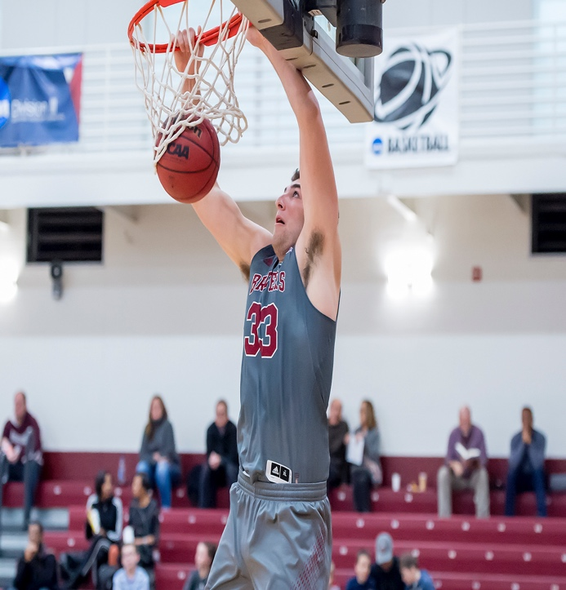

2019
VASSAR COLLEGE
BASKETBALL CAMP

BOYS - Ages 7-15

Session I – June 25-28
Cost - $250
3-Day Option - Wednesday-Friday - $195
Session II – July 30 - Aug 1
9:00AM – 4:00PM
DAILY SCHEDULE
8:30 Gym Open / Free Shoot
9:00 Roll Call
9:05 Warm-up / Stretch
9:20 Ball Handling / Shooting Progression
10:00 Teaching Stations (8)
11:00 Team Practice
11:15 5v5 Games / Free Throws
11:55 Lunch
12:00 Extra Instruction / Free Throws
1:00 Lecture / Group Instruction
1:30 Individual Competitions
2:00 Team Practices
2:15 5v5 Games / Free Throws
3:15 Team Competitions
3:45 Campers Dismissed
4:00 Gym open / Free Shoot

FACILITIES
The camp will be held indoors in the Athletics & Fitness Center and in Walker Fieldhouse.

A certified emergency medical technician or an athletic trainer will be available (Campers are required to provide their own coverage. See Parent’s Consent on the Application).

Meals will be prepared and eaten on campus
in Gordon Commons.

TUITION & PAYMENT
Tuition for the VC Basketball Camp is $250.
There is a $20 discount for additional siblings. Team discounts ($10 per camper) are available for teams of 5 or more. To register as a team, or if you have any other questions, contact Michael Callahan (845-437-7946 or micallahan@vassar.edu).

3-Day Option – Available due to Public School Calendar. Campers who sign up Wednesday-Friday will be seamlessly integrated into camp on arrival.

Register Online:
Please go to vassarsportscamps.com to register

